**WORLESTON & DISTRICT PARISH COUNCIL**

ANNUAL PARISH COUNCIL MEETING

To be held at Worleston Village Hall

7.00pm 22nd May 2025

**Clerk to the Parish Council:** Helen Exley, Daisy Bank Farm, off Top Farm Lane, Cholmondeston, Cheshire CW7 4DR 01270 528768

E mail: [clerk@worlestondistrict-pc.gov.uk](mailto:clerk@worlestondistrict-pc.gov.uk)

All members of the public are welcome to attend.

AGENDA

1. Election of Chairman for Worleston & District Parish Council
2. Election of Vice Chairman for Worleston & District Parish Council
3. Election of Responsible Financial Officer
4. Public Forum

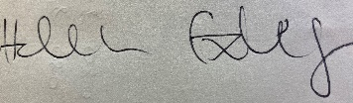

Helen Exley

Clerk  - Worleston Parish Council

12th May 2025